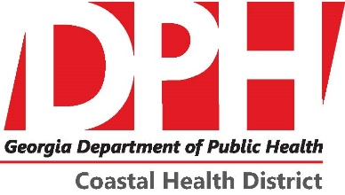 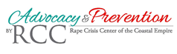

**Save a Life Youth Health Summit**

**Saturday, June 23rd at 9am -4pm**

**Youth Ages 10-19; Parents & Educators are welcome**

**Registration Form**

**Youth Participant**

**Name:____________________________________________**

**Phone:_________________ Email:________________________**

**Grade:_______________ Age:__________**

**Attending CPR Certification Class: YES or NO**

**Parent/Educator Participant**

**Name:____________________________________________**

**Phone:_________________ Email:________________________**

**Parent or Educator?__________________**

**Attending CPR Certification Class: YES or NO**