AFTER THE FLOOD: FOOD SERVICE ESTABLISHEMNTS
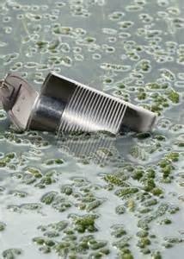
All restaurants affected by floodwaters MUST be inspected PRIOR to reopening. For more information, call your county Environmental Health office.

The following guidelines will help you clean up your facility to prepare for reopening:
- Assess damage and secure access to a potable water source.
- Clean the building safely!
  - Wear rubber boots, gloves, goggles, and coveralls
  - Wear a mask for mold protection
  - Dry water affected area quickly
- Clean all food handling and storage equipment.
  - Clean all hard surfaces with soap and water
  - Clean and sanitize all food contact surfaces before use
- Discard any UNSAFE food products.
- Discard damaged building items.
  - Discard all porous contaminated items that cannot be cleaned
When flooding occurs and food has been contaminated by flood or wastewater, the following precautions should be taken:

- Throw away any and all food that may have come in contact with flood or wastewater.
- Throw away any food that has an unusual odor, color, or texture.
- Throw away perishable foods (including meat, milk, poultry, fish, and eggs) that have been above 41°F for more than 2 hours.
- Frozen food that contains ice crystals and is 41°F or below can be refrozen or cooked unless contaminated by flood or wastewater.
- Canned goods may be salvaged if there is not can damage present. Can damage can be shown by swelling; leakage; punctures; holes; fractures; extensive deep rusting; or crushing/denting severe enough to prevent normal stacking or opening with a manual, wheel-type can opener.
- Cans must be re-labeled.
- Dispose of food containers with screw caps, snap-lids, crimped caps (soda pop bottles), twist caps, and caps that snap open that may have been contaminated by the flood or wastewater.
- Do not use contaminated water in icemakers, coffee makers, or soda pop dispensers.
- Do not use contaminated water to wash and prepare food or to wash hands before preparing or eating food.

FOR ADDITIONAL INFORMATION CONTACT YOUR COUNTY ENVIRONMENTAL HEALTH OFFICE.

